Image | 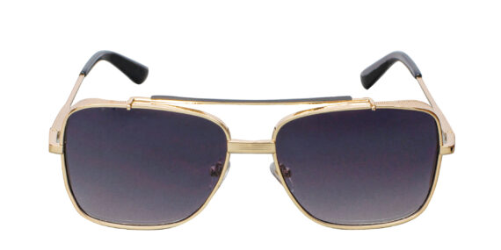
Brand | PRADA
Model Name | Audacieux SFG
Price | RS 2000
PRODUCT DETAILS

